## Prompt1:TPC

Promptv1:

Initial structure:

Clickable Buttons: ['Allow', 'Don’t allow']

Other Buttons: ['9:26', 'Digital Wellbeing notification: Need time to focus?', 'Settings notification: Virtual SD card', 'Wifi signal full.', 'Phone three bars.', 'Battery 100 percent.', 'Allow AnkiDroid to send you notifications?'].

click Allow.

Output structure:

Clickable Buttons: ['OK']

Other Buttons: ['9:26', 'Digital Wellbeing notification: Need time to focus?', 'Settings notification: Virtual SD card', 'Wifi signal full.', 'Phone three bars.', 'Battery 100 percent.', 'Welcome to AnkiDroid!', 'AnkiDroid requires storage permission, which we use exclusively to store your AnkiDroid collection, flashcard media and backups. Our code is open-source, written by volunteers, and trusted by millions.\n\nIf you have any questions, please access our in-app manual or visit our support forums.\n\nThank you for trying AnkiDroid!\n—AnkiDroid Development Team'].

click OK.

Output structure:

Clickable Buttons: ['Allow', 'Don’t allow']

Other Buttons: ['Allow AnkiDroid to access photos, videos, music, and audio on this device?', '9:27', 'Digital Wellbeing notification: Need time to focus?', 'Settings notification: Virtual SD card', 'Wifi signal full.', 'Phone two bars.', 'Battery 100 percent.'].

click Allow.

Output structure:

Long Clickable Buttons: ['Navigate up', 'Search decks', 'Sync (log in)', 'More options', 'Add']

Other Buttons: ['9:27', 'Digital Wellbeing notification: Need time to focus?', 'Settings notification: Virtual SD card', 'Wifi signal full.', 'Phone signal full.', 'Battery 100 percent.', 'AnkiDroid', '0 cards due (0 s)', '11', '0', '0', '0', '2', '0', '0', '0', '22', '0', '0', '0', '3', '0', '0', '0', '33', '0', '0', '0', '4', '0', '0', '0', '5', '0', '0', '0', '6', '0', '0', '0', '7', '0', '0', '0', '8', '0', '0', '0', '9', '0', '0', '0', 'lol', '0', '0', '0', 'Studied 0 cards in 0 minutes today'].

click Navigate up.

Output structure:

Long Clickable Buttons: ['Decks', 'Card browser', 'Statistics']

Clickable Buttons: ['OFF']

Other Buttons: ['9:27', 'Digital Wellbeing notification: Need time to focus?', 'Settings notification: Virtual SD card', 'Wifi signal full.', 'Phone signal full.', 'Battery 100 percent.', 'Night mode', 'Settings', 'Help'].

click Help.

Output structure:

Clickable Buttons: ['Using AnkiDroid', 'Get Help', 'Support AnkiDroid', 'Community']

Other Buttons: ['Help', '9:28', 'Digital Wellbeing notification: Need time to focus?', 'Settings notification: Virtual SD card', 'Wifi signal full.', 'Phone signal full.', 'Battery 100 percent.'].

click Get Help.

Output structure:

Clickable Buttons: ['Mailing List', 'Report a Bug', 'Send troubleshooting report']

Other Buttons: ['Get Help', '9:28', 'Digital Wellbeing notification: Need time to focus?', 'Settings notification: Virtual SD card', 'Wifi signal full.', 'Phone signal full.', 'Battery 100 percent.'].

click Send troubleshooting report.

Output structure:

Clickable Buttons: ['Mailing List', 'Report a Bug', 'Send troubleshooting report']

Other Buttons: ['Get Help', '9:28', 'Digital Wellbeing notification: Need time to focus?', 'Settings notification: Virtual SD card', 'Wifi signal full.', 'Phone signal full.', 'Battery 100 percent.'].

click Cancel.

Output structure:

Clickable Buttons: ['Mailing List', 'Report a Bug', 'Send troubleshooting report']

Other Buttons: ['Get Help', '9:29', 'Digital Wellbeing notification: Need time to focus?', 'Settings notification: Virtual SD card', 'Wifi signal full.', 'Phone three bars.', 'Battery 100 percent.'].

click Send troubleshooting report.

Output structure:

Clickable Buttons: ['Mailing List', 'Report a Bug', 'Send troubleshooting report']

Other Buttons: ['Get Help', '9:29', 'Digital Wellbeing notification: Need time to focus?', 'Settings notification: Virtual SD card', 'Wifi signal full.', 'Phone two bars.', 'Battery 100 percent.'].

Above is an app flow, containing page text and actions to reach other pages. Ignore battery, time and signal fluctuates in page content and coordinate in actions, and do not evaluate them in the following question. Is there any inconsistency, a discrepancy, a logical error, or a bug in the output after the given test sequence? Provide your answer with yes or no, and the reason. The reason should be brief and concise.

### Answers:

Yes, there is a logical error in the output after clicking "Send troubleshooting report" for the first and second time. The output structure does not change, indicating that the action did not lead to any change in the application's state or provide feedback to the user on the action taken, which is inconsistent with typical app behavior when performing a task like sending a report.

## Prompt2: FP

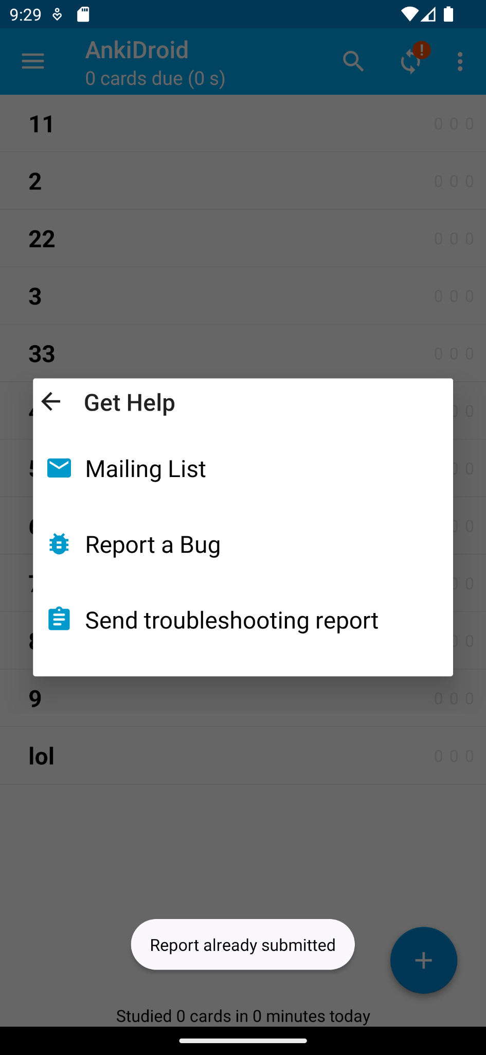

This is the last page screenshot of the above app flow. Is there any inconsistency, a discrepancy, a logical error, or a bug in the output after the given test sequence? Provide your answer with yes or no, and the reason. The reason should be brief and concise.

### Answers:

No, there is no inconsistency, discrepancy, or logical error given the screenshot. The screenshot displays a message "Report already submitted" which indicates feedback was provided to the user after an action was taken, which was not mentioned in the text description of the app flow. This implies the application did register the action of sending a troubleshooting report and provided a response accordingly.

## Prompt3: TPC

Prompt v3:

Action List:

click Allow

click OK

click Allow

click Navigate up

click Help

click Get Help

click Send troubleshooting report

click Cancel

click Send troubleshooting report

Final output structure:

Clickable Buttons: ['Mailing List', 'Report a Bug', 'Send troubleshooting report']

Other Buttons: ['Get Help', '9:29', 'Digital Wellbeing notification: Need time to focus?', 'Settings notification: Virtual SD card', 'Wifi signal full.', 'Phone two bars.', 'Battery 100 percent.']

Above is an app flow, containing the actions from the first page to reach other pages and the last page text. Ignore battery, time and signal fluctuates in page content and coordinate in actions, and do not evaluate them in the following question. Is there any inconsistency, a discrepancy, a logical error, or a bug in the output after the given test sequence? Provide your answer with yes or no, and the reason. The reason should be brief and concise.

### Answers:

Yes, there is a discrepancy. The "Send troubleshooting report" button is clicked twice in the action list, suggesting it should be a part of the user's journey within the app. However, in the final output structure, it is listed under "Clickable Buttons," implying that the user has not yet interacted with it or it leads to another action rather than concluding the journey. This discrepancy suggests a logical error in how the action list corresponds to the final output structure.

## Prompt4: TPC

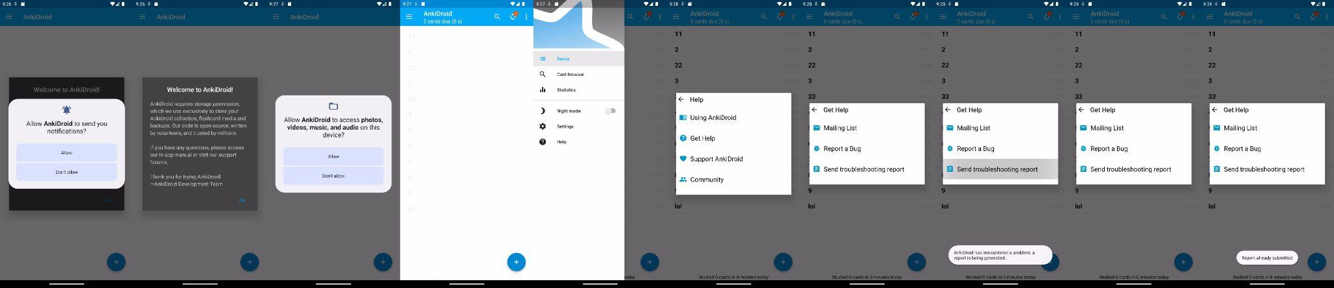

Attached is the screenshot page sequence of an app flow. Ignore battery, time and signal fluctuates in page content and coordinate in actions, and do not evaluate them in the following question. Is there any inconsistency, a discrepancy, a logical error, or a bug in the output after the given test sequence? Provide your answer with yes or no, and the reason. The reason should be brief and concise.

### Answers:

Yes, there is an inconsistency in the sequence. After the user submits a bug report, the final screen should display a confirmation that the report has been submitted. Instead, the final screen erroneously shows the option to "Send troubleshooting report" as if the report has not been submitted, which is inconsistent with the user's previous action of submitting a report.

## Prompt5: TPW

Sequence page structure:

Clickable Buttons: ['Allow', 'Don’t allow']

Other Buttons: ['9:26', 'Digital Wellbeing notification: Need time to focus?', 'Settings notification: Virtual SD card', 'Wifi signal full.', 'Phone three bars.', 'Battery 100 percent.', 'Allow AnkiDroid to send you notifications?']

Clickable Buttons: ['OK']

Other Buttons: ['9:26', 'Digital Wellbeing notification: Need time to focus?', 'Settings notification: Virtual SD card', 'Wifi signal full.', 'Phone three bars.', 'Battery 100 percent.', 'Welcome to AnkiDroid!', 'AnkiDroid requires storage permission, which we use exclusively to store your AnkiDroid collection, flashcard media and backups. Our code is open-source, written by volunteers, and trusted by millions.\n\nIf you have any questions, please access our in-app manual or visit our support forums.\n\nThank you for trying AnkiDroid!\n—AnkiDroid Development Team']

Clickable Buttons: ['Allow', 'Don’t allow']

Other Buttons: ['Allow AnkiDroid to access photos, videos, music, and audio on this device?', '9:27', 'Digital Wellbeing notification: Need time to focus?', 'Settings notification: Virtual SD card', 'Wifi signal full.', 'Phone two bars.', 'Battery 100 percent.']

Clickable Buttons: []

Other Buttons: ['9:27', 'Digital Wellbeing notification: Need time to focus?', 'Settings notification: Virtual SD card', 'Wifi signal full.', 'Phone signal full.', 'Battery 100 percent.', 'AnkiDroid', '0 cards due (0 s)', '11', '0', '0', '0', '2', '0', '0', '0', '22', '0', '0', '0', '3', '0', '0', '0', '33', '0', '0', '0', '4', '0', '0', '0', '5', '0', '0', '0', '6', '0', '0', '0', '7', '0', '0', '0', '8', '0', '0', '0', '9', '0', '0', '0', 'lol', '0', '0', '0', 'Studied 0 cards in 0 minutes today']

Clickable Buttons: ['OFF']

Other Buttons: ['9:27', 'Digital Wellbeing notification: Need time to focus?', 'Settings notification: Virtual SD card', 'Wifi signal full.', 'Phone signal full.', 'Battery 100 percent.', 'Night mode', 'Settings', 'Help']

Clickable Buttons: ['Using AnkiDroid', 'Get Help', 'Support AnkiDroid', 'Community']

Other Buttons: ['Help', '9:28', 'Digital Wellbeing notification: Need time to focus?', 'Settings notification: Virtual SD card', 'Wifi signal full.', 'Phone signal full.', 'Battery 100 percent.']

Clickable Buttons: ['Mailing List', 'Report a Bug', 'Send troubleshooting report']

Other Buttons: ['Get Help', '9:28', 'Digital Wellbeing notification: Need time to focus?', 'Settings notification: Virtual SD card', 'Wifi signal full.', 'Phone signal full.', 'Battery 100 percent.']

Clickable Buttons: ['Mailing List', 'Report a Bug', 'Send troubleshooting report']

Other Buttons: ['Get Help', '9:28', 'Digital Wellbeing notification: Need time to focus?', 'Settings notification: Virtual SD card', 'Wifi signal full.', 'Phone signal full.', 'Battery 100 percent.']

Clickable Buttons: ['Mailing List', 'Report a Bug', 'Send troubleshooting report']

Other Buttons: ['Get Help', '9:29', 'Digital Wellbeing notification: Need time to focus?', 'Settings notification: Virtual SD card', 'Wifi signal full.', 'Phone three bars.', 'Battery 100 percent.']

Clickable Buttons: ['Mailing List', 'Report a Bug', 'Send troubleshooting report']

Other Buttons: ['Get Help', '9:29', 'Digital Wellbeing notification: Need time to focus?', 'Settings notification: Virtual SD card', 'Wifi signal full.', 'Phone two bars.', 'Battery 100 percent.']

Above is an app flow, containing the actions from the first page to reach other pages and the last page text. Ignore battery, time and signal fluctuates in page content and coordinate in actions, and do not evaluate them in the following question. Is there any inconsistency, a discrepancy, a logical error, or a bug in the output after the given test sequence? Provide your answer with yes or no, and the reason. The reason should be brief and concise.

### Answers:

Yes, there's an inconsistency in the transition from the third page to the fourth page. The third page asks for permission to access photos, videos, music, and audio, but the fourth page suddenly transitions to an AnkiDroid screen showing '0 cards due' without indicating whether the permission was granted or what action was taken following the permission request. This leap suggests a missing step or feedback to the user regarding the permission action.

## Result Analysis

After the question prompt changed, the accuracy of the explanation also increased.

The wrong answer to prompt 5 shows that we need to provide actions.